Difference between SOAP API and REST API
Let’s break this down trainer-style, from basics → comparison → real-world usage 👍
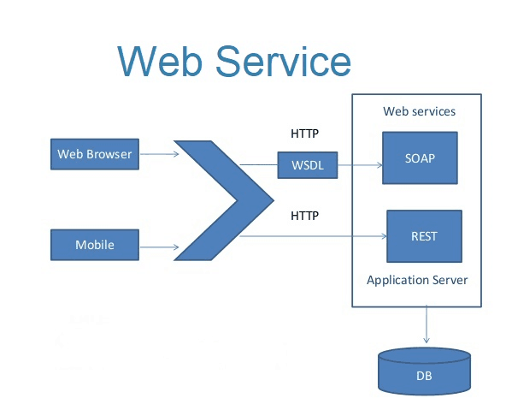
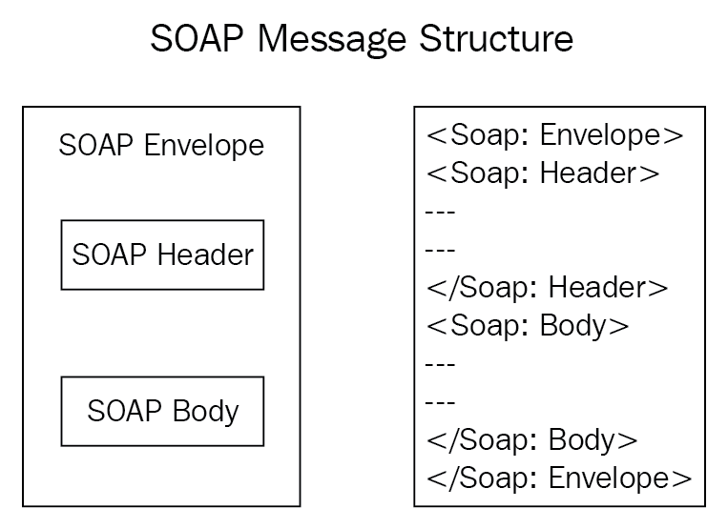
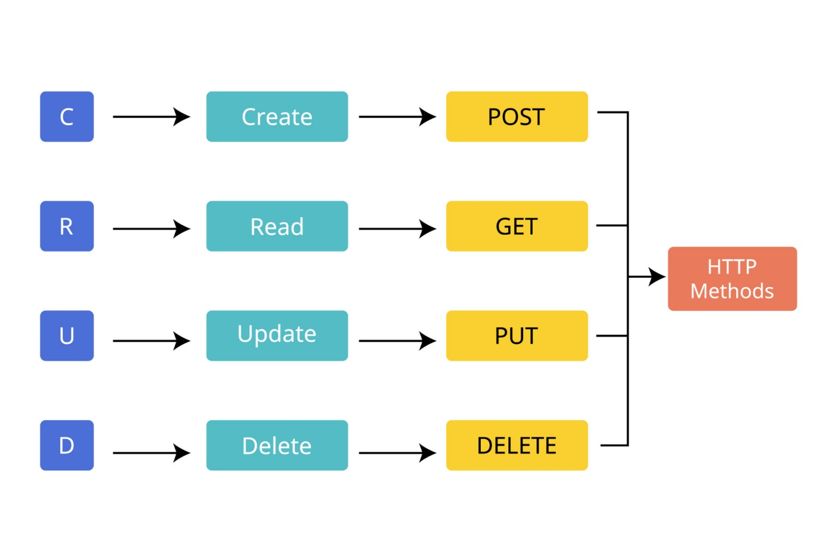
4

1️⃣ What is SOAP API?
SOAP (Simple Object Access Protocol) is a strict, protocol-based web service standard.
Key points
- Uses XML only
- Has strict rules and structure
- Works over HTTP, HTTPS, SMTP
- Comes with built-in security & reliability
SOAP Message Structure
<Envelope>
<Header>
<!-- Security, Authentication -->
</Header>
<Body>
<!-- Actual Request / Response -->
</Body>
</Envelope>
When SOAP is used
- Banking systems 🏦
- Payment gateways 💳
- Enterprise applications
- Systems needing high security & transactions

2️⃣ What is REST API?
REST (Representational State Transfer) is an architectural style, not a protocol.
Key points
- Works mainly over HTTP/HTTPS
- Supports multiple data formats:
  - JSON (most common)
  - XML
  - Plain text
- Lightweight and easy to use
- Uses HTTP methods directly
REST HTTP Methods
Method | Meaning
GET | Read data
POST | Create data
PUT | Update data
DELETE | Remove data
Example REST URL
GET https://api.company.com/employees/101
When REST is used
- Mobile apps 📱
- Web apps 🌐
- Microservices
- Cloud APIs

3️⃣ SOAP vs REST – Side-by-Side Comparison
Feature | SOAP | REST
Type | Protocol | Architecture style
Data format | XML only | JSON, XML, Text
Complexity | High | Simple
Performance | Slower (XML heavy) | Faster (JSON light)
Security | Built-in (WS-Security) | Uses HTTPS, OAuth, JWT
Flexibility | Low | High
Caching | Not supported | Supported
Learning curve | Steep | Easy

4️⃣ Example Comparison
SOAP Request (Heavy)
<soap:Envelope>
<soap:Body>
<getEmployee>
<id>101</id>
</getEmployee>
</soap:Body>
</soap:Envelope>
REST Request (Simple)
GET /employees/101

5️⃣ Real-World Analogy 🧠
SOAP
📄 Official Government Letter
- Fixed format
- Formal
- Secure
- Slower but reliable
REST
💬 WhatsApp Message
- Simple
- Fast
- Flexible
- Easy to integrate

6️⃣ Which One Should You Choose?
Use SOAP if:
✔ Financial transactions
✔ Enterprise-grade security
✔ ACID compliance required
Use REST if:
✔ Web & mobile apps
✔ Microservices
✔ High performance & scalability

7️⃣ Interview One-Line Answer 💡
SOAP is a protocol with strict standards using XML, while REST is a lightweight architectural style using HTTP methods and commonly JSON.

